Artefact Take Home Assignment
JAD KRISHT
This report summarizes the steps taken to clean and transform the "Customer Reviews" data set, extract sentiment and themes from each review, build EDA charts, and provide recommendations for the top 20 businesses by review count.
The complete analysis, including code, visualizations, and intermediate outputs, is documented in a Jupyter Notebook available on GitHub:
GitHub Repository: https://github.com/jadkrisht98/Artefact_Project/blob/main/Final_Notebook.ipynb

- Methodology:
  - Data Transformation & Preprocessing:
The dataset underwent several preprocessing steps to ensure data quality and analytical reliability. These steps included:
- Handled missing values — identified rows with null ratings (whose content was also unclear) and dropped them.
- Removed duplicates — checked for and dropped duplicate rows (ignoring the tags column, since the same review can have different tags).
- Removed emoji-only reviews — found rows where the review content was nothing but emojis (no actual text) and dropped them, since they carry no analyzable information.
- Extracted tag details — split each tag dictionary into separate columns (tag, sentiment) and merged with the JSON lookup table to add offering and destination columns.
- Extracted rating details — split each rating dictionary into normalized_rating and actual_rating columns.
- One-hot encoded offerings — converted the offering column into four binary (0/1) flag columns, one per offering category. Then grouped back to one row per review, so each review shows which offerings it relates to.
- Resolved multiple destinations — when a review was linked to multiple destinations (from multiple tags), kept only the most frequently occurring destination for that review.
- Re-normalized all ratings to a 0–100 scale — applied a simple rule: multiply the actual rating by 20 (so 1→20, 2→40, …, 5→100), and cap anything above 5 at 100. This ensures a consistent 0–100 normalized scale regardless of the original rating system.

Sample data frame is snap below:
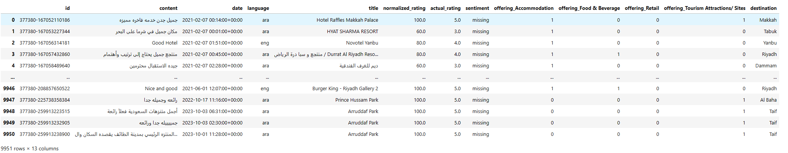
  - Sentiment Analysis:
I conducted sentiment analysis on customer reviews using two distinct methods: (1) a lexicon-based approach, and (2) a deep learning technique utilizing a pre-trained large language model (LLM).
For the lexicon-based method, I employed the TextBlob library, which assigns sentiment scores to individual words in the text and calculates an overall sentiment for each review. This approach is straightforward and works well for English-language content, but unfortunately, I could not find an equivalent library for Arabic text, limiting its use to English reviews only.
For the deep learning approach, I utilized a task-specific LLM model called twitter-XLM-roBERTa (link), which is designed for multilingual sentiment analysis. This model consists of two main components: the XLM-RoBERTa pre-trained LLM that generates contextual word embedding, and an additional neural network layer that classifies each review as positive, neutral, or negative.
The model is integrated via the tweetnlp library (link), enabling robust sentiment classification across multiple languages, including both English and Arabic reviews.
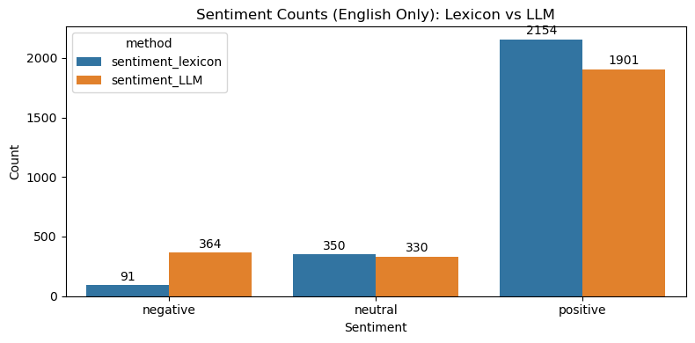
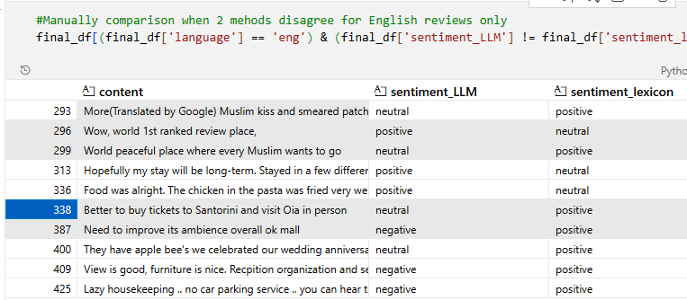
I compared the 2 models (English reviews only) manually by looking at 20 samples. The LLM based approach is much more reliable and precise. A sample is attached below:

  - Text Cleaning:
The text contains few misalignments, the follow steps were taken to clean the text:
- Translation handling: Reviews that include both original Arabic and Google-translated English are split to keep only the translated English segment; the language is forced to English for those rows.
- Language validation: A rule-based checker (Arabic vs English character detection) flags mismatches and updates the language column when confidently identified as English or Arabic.
- English cleaning: Non-letter characters are removed, text is lowercased, English stopwords are removed, and tokens are lemmatized.
- Arabic cleaning: Diacritics are removed, non-Arabic characters are stripped, text is tokenized with an Arabic tokenizer, and Arabic stopwords are removed.

Output: A cleaned field clean_content is created and used for downstream NLP; the original content column is dropped afterward.

  - Theme/topic extraction
For deriving themes out of the reviews, I used 2 methods, (1) Topic Modeling via LDA (Latent Dirichlet Allocation) - classic probabilistic approach, and (2) Ensemble ML model – BERTopic.
For method (1) I trained an LDA model with 5 topics, listed the top words per topic, then manually named each topic as a theme. For each review/content, I selected the most likely topic and stored its theme label in the dataset.

Topic 1 | جدا, جميل, مكان, الله, ممتاز, فندق, المكان, الفندق, رائع, جيد, نظيف, الاستقبال, يوجد, ونظيف | Accommodation & Positive Venue Experience
Topic 2 | place, good, nice, beautiful, one, best, restaurant, food, great, visit, service, family, excellent, park | Food & Dining / Restaurants
Topic 3 | ممتاز, رائع, god, mosque, جميلة, may, prayer, حديقة, peace, جدا, تحتاج, جميله, oh, upon | Religious / Spiritual & Tranquil Sites
Topic 4 | افضل, الرياض, سوق, يوجد, مكان, مول, يحتاج, أجمل, جميلة, او, جيده, حديقة, المملكة, شي | City Amenities & Shopping (Riyadh-focused)
Topic 5 | جميله, شي, المكان, قلعة, اللي, اجمل, مارد, الفندق, علي, القلعة, بقاع, الأرض, نصيف, الملك | Attractions & Scenic / Heritage Sites

Review count per theme:
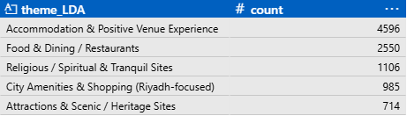

However, method (1) is very manual to label and limited as it doesn’t consider the contextual meaning of the word (same word could have different meaning in different reviews). So, alternatively I considered a more advanced methodology - BERTopic.
For method (2). I used an ensemble model /pipeline called “BERTopic” (link to repo) created by Maarten Grootendorst. In summary it’s a topic-modeling method that clusters document embeddings and extracts topic keywords with TF-IDF.
BERTopic is a pipeline that combines multiple steps:
- Create vector embeddings via BERT
- Cluster reviews via HDBSCAN
- TF-IDF keyword extraction (top 10)
- Optional Representation model to name themes (I used OpenAI gpt-4.1 model)

I chose the model to produce 20 themes/topic, below is a snapshot from the code with final topic names and count. Please refer to GitHub repo for full detailed code.
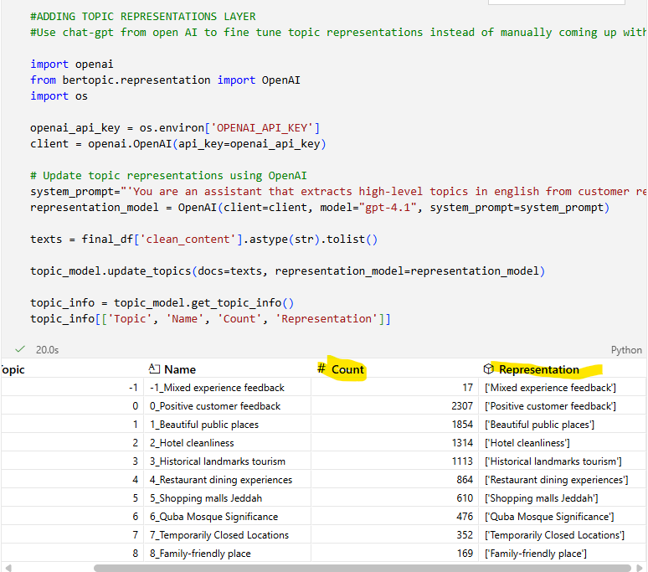
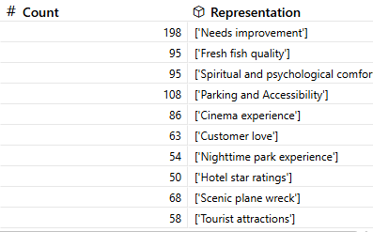
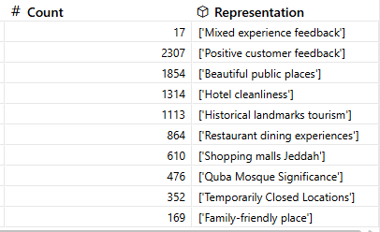

The data is now clean, with sentiment analysis and topic extraction complete—ready for EDA and model training/testing.

- Findings:
  - Insights from Common Keywords and Themes:
Top 20 common words used in the reviews based on TF-IDF scores are:

With جميل, جدا, ممتاز, رائع, مكان being in top 5

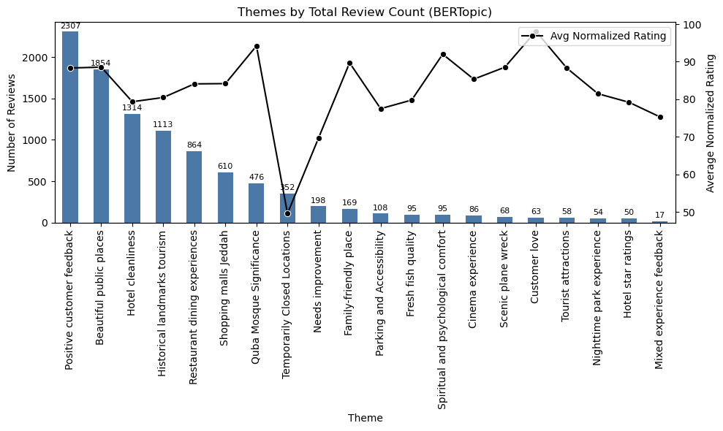
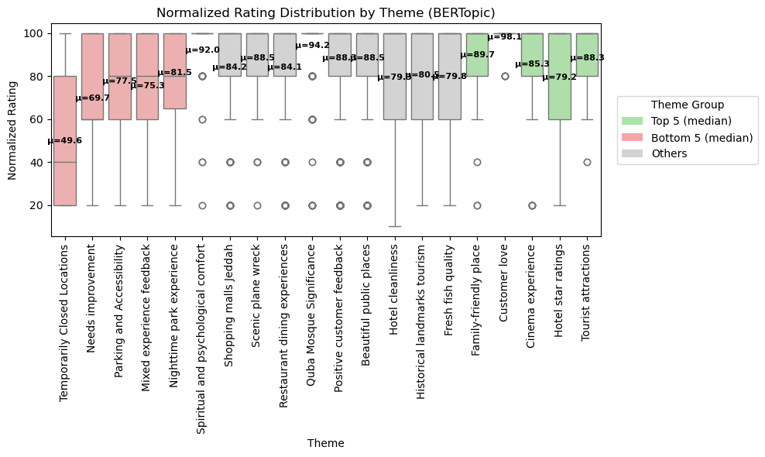
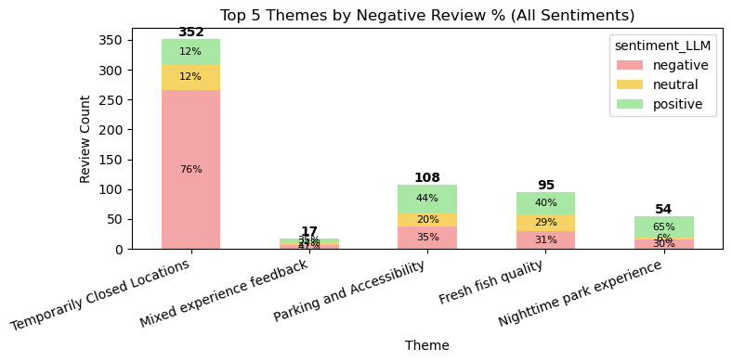

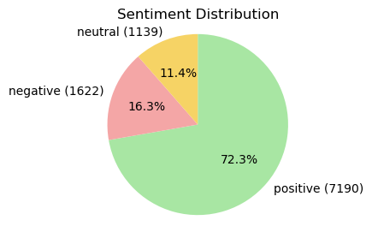
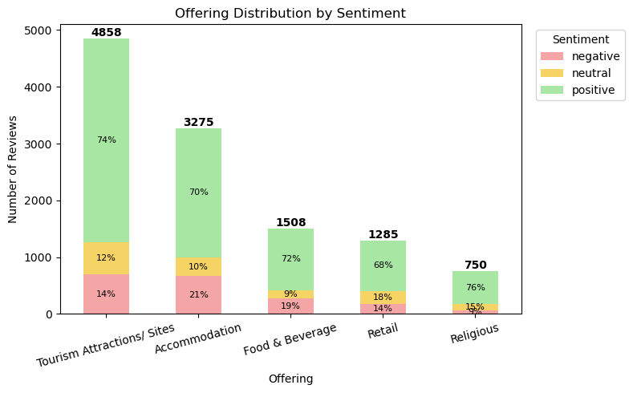
  - Insights from Sentiment Analysis:

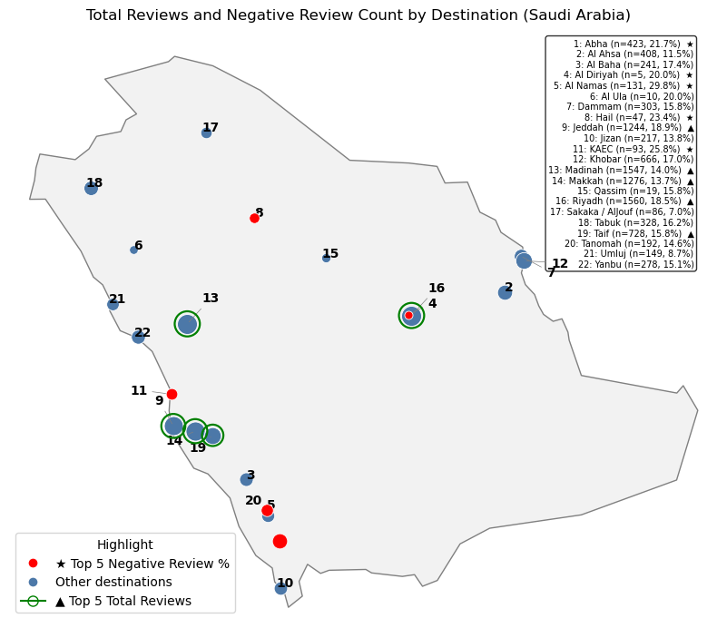
  - Other insights from EDA:
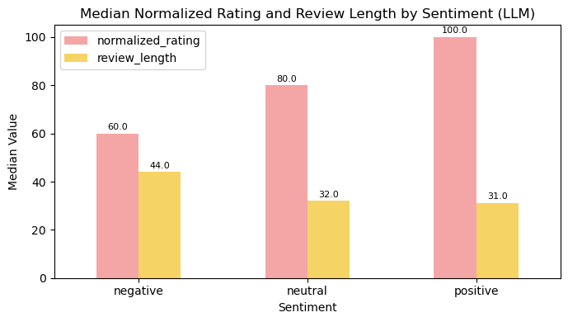
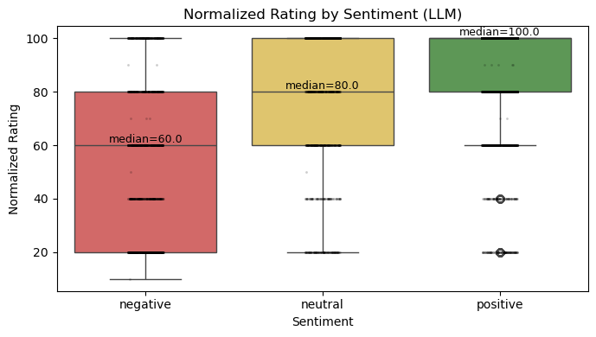

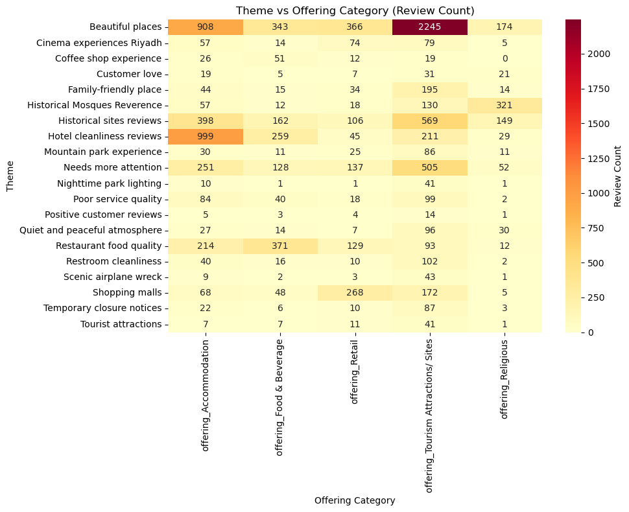

- Recommendation:

